Quiz#5 section A (TOTAL 10marks)

Roll#-----------------------------

Q1. (marks 3)

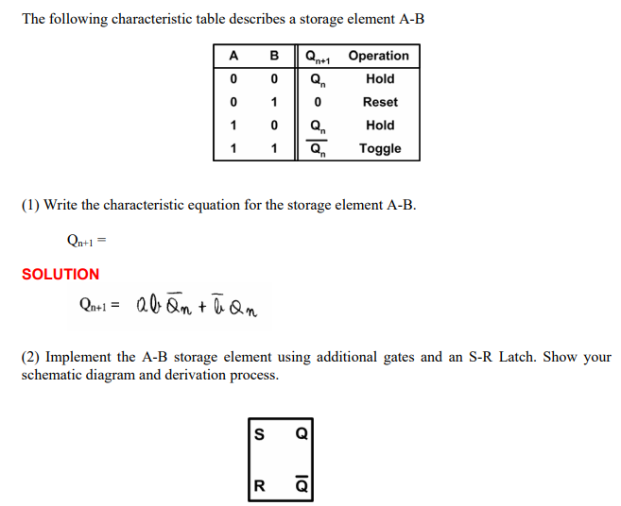

Q2. (marks 4)

Design a sequential circuit with two D flip-flops A and B and one input X. When X = 0, the state of the circuit remains the same. When X = 1, the circuit goes through the state transitions from 00 to 10 to 11 to 01, back to 00, and then repeats.

Q3. (marks 3)

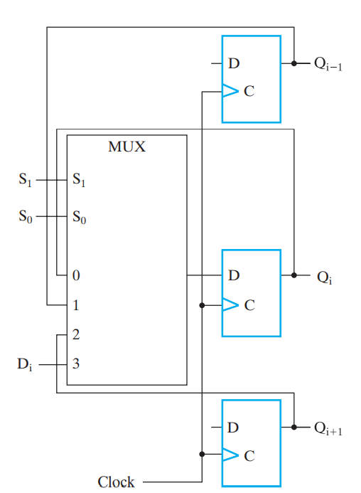

Modify the register so that it will operate according to the following function table, using mode selection inputs S1 and S0 :

